Ideation Phase

Define the Problem Statements

|  |  |
| --- | --- |
| Date | 04 October 2022 |
| Team ID | PNT2022TMID12468 |
| Project Name | Containment Zone Alerting Application |
| Maximum Marks | 2 Marks |

# Customer Problem Statement Template:

Create a problem statement to understand your customer's point of view. The Customer Problem Statement template helps you focus on what matters to create experiences people will love.

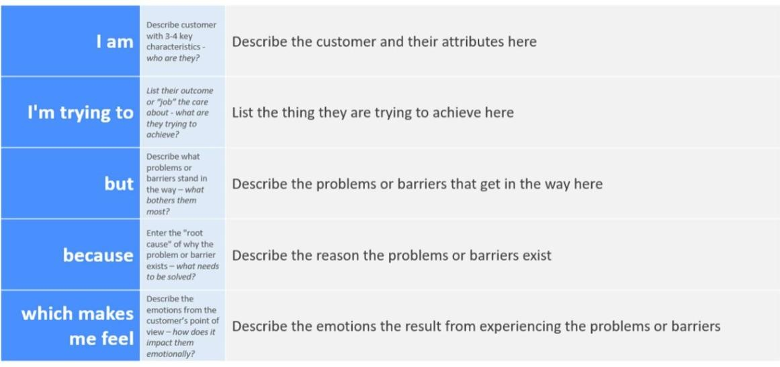A well-articulated customer problem statement allows you and your team to find the ideal solution for the challenges your customers face. Throughout the process, you’ll also be able to empathize with your customers, which helps you better understand how they perceive your product or service.

Reference: https://miro.com/templates/customer-problem-statement/

# Example:

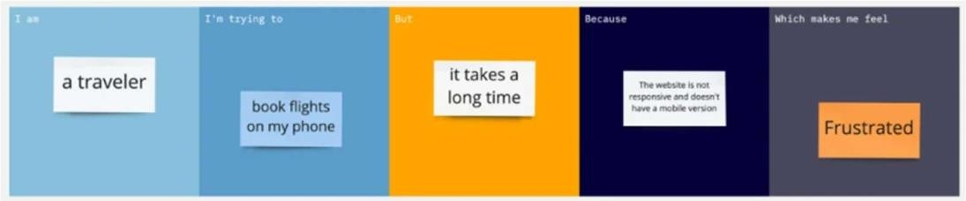

|  |  |  |  |  |  |
| --- | --- | --- | --- | --- | --- |
| **Problem Statement (PS)** | **I am (Customer)** | **I’m trying to** | **But** | **Because** | **Which makes me feel** |
| Problem Statement-1 | User | Know the containment area | The searching technique is not good | Of the apps didn’t show a perfect accurate area | Irritating |
| Problem Statement -2 | User | Explore the application | The UI is not good when I trying to access in mobile and laptop | The design of UI is not reliable and the backend is also bad | Frustrated |
| Problem Statement -3 | User | Can’t know the effective region or places accurately | The UI didn’t show in a correct manure | The design of UI in not good | Irritating |
| Problem Statement -4 | Social worker | Give awareness about the infection | Don’t know about the containment zone | Need to maintain the containment free zone | irritating |